Updated methodology for Data Selection and Groundwater Level Trend Analysis

|  |  |
| --- | --- |
| Title: | Updated methodology for Data Selection and Groundwater Level Trend Analysis |
| Version: | Final #1 |
| Date: | 14th December 2023 |
|  |  |
| Authors: | Sebastian Pacheco, Arnaud Sterckx, Elie Gerges |
|  |  |
| Lead organization | International Groundwater Resources Assessment Centre (IGRAC) |
| Address: | Westvest 7 2611AX Delft The Netherlands |
| Website: | [www.un-igrac.org](http://www.un-igrac.org) |
| Points of contact | Sebastian Pacheco Mercado, [sebastianpacheco@unap.cl](mailto:sebastianpacheco@unap.cl)  Arnaud Sterckx, [armaud.sterckx@un-igrac.org](mailto:armaud.sterckx@un-igrac.org) |

# Introduction

In 2023, IGRAC coordinated the section dedicated to groundwater levels in the State of Global Water Resources 2022 report[1] published by the World Meteorological Organization (WMO). The section contained an assessment of groundwater based on in-situ groundwater level monitoring data. The interpretation of the data consisted in the evaluation of linear regression trends and the ranking of groundwater levels, based on groundwater-level composite hydrographs calculated over aquifers or other relevant reporting units. This methodology was piloted in 10 countries, where data from the national groundwater monitoring networks were available, using a period of record of 10 years (2013–2022).

The methodology had some limitations, and it will be consolidated for the next edition of the report. One main modification is that the interpretation of time series (trend analysis and ranking) will be performed at the monitoring station level. The results will be subsequently aggregated at the aquifer (or other relevant reporting unit) level, wherever such information is available. Another modification concerns the selection of the data. In the last report, time series were selected if they contained at least 4 monthly values per year, on average, and no more than 1 year without any data. These selection criteria were problematic because i) the frequency of groundwater level monitoring is often less than 4 measurements per year, in many countries, and ii) there was no requirement as of the distribution and the consistency of the measurements throughout the year and across the years. This reports describes an improved methodology for selecting the data, and the work that has been carried out to develop it. This report also evaluates the appropriate use of the Mann-Kendall test for trend analysis, instead of the linear regression that was used previously, with regard to the auto-correlation issues in the selected time series.

The work presented in this report was carried out by Sebastian Pacheco, from Universidad Arturo Prat in Chile, who was hosted at IGRAC as a visiting scholar in Autumn 2023.

# Background

The consistency of groundwater level monitoring data is essential for time series analysis. However, groundwater monitoring practices vary between countries, and even sometimes within the same organization, depending on available budgets, priorities, cycles of assessment/optimization of the monitoring programs, internal management changes, etc. This can affect several aspects of monitoring, including the frequency of monitoring, the period of monitoring (e.g. wet season, dry season), the spatial distribution and representativeness of monitoring stations, etc. It is therefore challenging to define data selection criteria that can be applied worldwide, in a variety of countries and contexts. On one hand, setting strict selection criteria will reduce the number of selected wells, with low spatial representativeness but high precision of the information provided. On the other hand, choosing looser selection criteria could result in greater spatial representativeness but with less reliability.

Moreover, the selection of time series data goes hand in hand with the selection of the trend analysis method. Various methods exist for trend analysis in time series, with the Mann Kendall test being a popular choice for assessing trends in hydroclimate and water variables (Fu et al., 2022), including groundwater levels. This method offers advantages such as handling non-normality, missing values, and seasonality,among others (Hirsch et al., 1982).

The effectiveness of the Mann-Kendall test relies on the important assumption that data are independent (not correlated). The identification of positive serial correlation raises the probability of the Mann-Kendall test detecting a trend, even in the absence of an actual trend. Nonetheless, it is not uncommon for some hydrological series to exhibit serial correlation (Daneshvar Vousoughi et al., 2013). Two principal strategies have been suggested to mitigate the effects of serial correlation, the first is **pre-treating the data**, and the second is **modifying the Mann-Kendall test** to account for serial correlation (Hamed, 2008). However, in the end, the debate over various approaches to handling serial correlation and trends becomes a mathematical exercise that trades off the significance and power of the Mann-Kendall test (Wang et al., 2020). In the examination of groundwater level trends, researchers have employed both strategies interchangeably. For instance, Le Brocque et al. (2018) and Daneshvar Vousoughi et al. (2013) utilized pre-treatment in regional studies. In contrast, the French Geological Survey (BGRM) opted for the modified Mann-Kendall test for national reporting (Croiset et al., 2018). Numerous studies worldwide that focus on analysing groundwater level trends, especially when data is collected monthly, often employ either an annual mean or choose specific months for season-based analysis (Barclay and Mullaney, 2020; Fu et al., 2022; Le Brocque et al., 2018; Pathak and Dodamani, 2019; Tabari et al., 2012). Serial correlation is then rarely observed, and as a result, the Mann-Kendall test is often recommended for trend analysis or supplemented with both techniques to address serial correlation.

Wang et al. (2020) underscores the limitations of the Mann-Kendall test, particularly when dealing with small sample sizes and high sample variability. To improve the effectiveness of the test, researchers may consider adjusting the significance level, from 0.05 (which is often used per-default) to 0.1, or extending the time series.

# Methodology

## Data selection

The proposed data selection methodology consists in selecting time series with as little as one measurement per year, as long as the measurements have been taken each year at the same period of the year. This is to avoid inconsistent time series comprising measurements taken during different seasons. It is not possible to work with seasons at the global level, because seasons vary from place to place. Therefore the methodology is based on calendar months. It works as follow (Figure 1):

1. The length of the time series must be chosen. For most hydrological variables, a 30-years period of records is recommended. However, many countries don’t have such long time series. A 20-years period could be considered, as well as a shorter period (5 or 10 years). It is also necessary to define a threshold for accepting/rejecting time series with data gaps. Over a period of 20 years, a threshold of 90% would result in the rejection of time series with more than 2 years without data, whereas a threshold of 80% would accept up to 4 years without data.
2. If necessary, suspicious data are discarded (e.g. -9999, 0 or negative values).
3. Data are resampled on a monthly basis.
4. Each time series is split into 12 time series, one for each month of the year. The number of available values in each monthly time series is counted, and the 12 time series are sorted accordingly, in descending order.
5. Following that order, each monthly time series undergoes the following steps:

* If there is no missing value (it possess a value for each year), all values are stored in the final time-series.
* If there are missing values, adjacent values are sought to fill in the gaps, as follow:
  + If values from the preceding and succeeding months are available, the mean of these two values is calculated and retained. The two adjacent values remain available to complement other monthly time series.
  + If only adjacent value is available, that value is retained but it is no longer available to complement other monthly time series.

If the number of values of the monthly time series meets the threshold that has been previously defined, the values are taken into consideration for the trend analysis. If not, the values are discarded.

Figure 1. Flow diagram of the data selection methodology

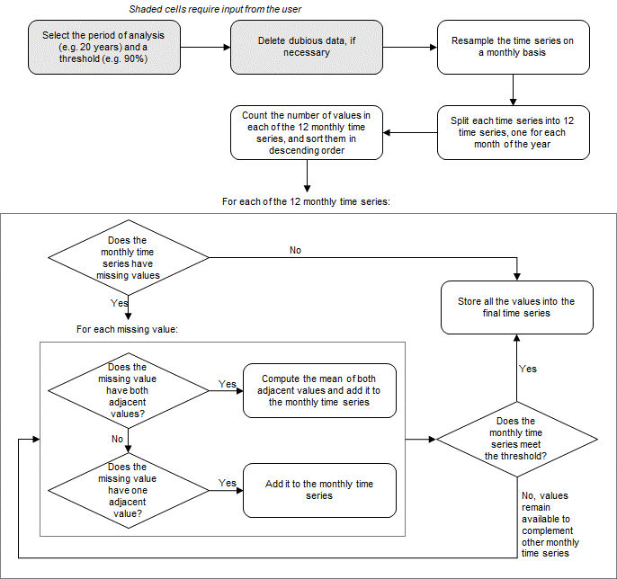

## Trend analysis

In the next edition of the State of Global Water Resources report, it is recommended to use the Mann-Kendall test. Yet, using this test requires some additional considerations. As a result of the new data selection methodology, the number of monthly values in the time series could be anything between 18 and 240, over a 20-year period and assuming a selection threshold of 90%. With time series presenting as little as 18 values, type 1 errors could occur, meaning that a true trend may exist, but the Mann-Kendall test incorrectly rejects the null hypothesis. This can be addressed by lowering the significance of the test.

Since the new data selection methodology guarantees an even distribution of values over the time series, it is not necessary to calculate an annual mean. Calculating annual means would require an additional step and would reduce the number of values, which is in contradiction with the recommendation to have more data to enhance the statistical power of the Mann-Kendall test.

In conclusion, it is recommended to apply the Mann-Kendall test over the selected data with a 90% significance level, unless there is serial correlation. In case of auto-correlation, the Modified Mann-Kendall (Hamed and Rao, 1998) test will be employed.

## Programming

The entire data selection and trend analysis methodology was programmed using Python 3. For the Mann-Kendall test, the pyMannKendall package (Hussain and Mahmud, 2019) was utilized, and the routines are accessible on GitHub[2]. Additionally, QGIS version 3.30 was employed for spatial analysis and visualizations.

## Case-studies

The new data selection and trend analysis methodology was piloted with groundwater level monitoring data from the Ogallala Aquifer, in USA, and from Chile. The timeframe for the current analysis covers the period from 1/1/2001 to 31/12/2020. Both 90% and 80% selection thresholds were tested. A more detailed analysis is presented for the Ogallala Aquifer to describe the proposed methodology. The analysis is more concise in the case of Chile.

* **Ogallala Aquifer, USA**

Groundwater monitoring data were downloaded from the National Ground-Water Monitoring Network[3], which compiles groundwater monitoring data collected by federal, state, and local monitoring programs over the USA. Water level trends were calculated and subsequently aggregated over the states that measure on the Ogallala Aquifer of the United States.

* **Chile**

Groundwater monitoring data were obtained from the General Water Directorate (*Dirección General de Aguas*). Data can also be downloaded from the website of the Directorate[4] per monitoring well. Water level trends were calculated and subsequently aggregated over the aquifers identified under the national inventory of aquifers of 2023 (*Inventario Nacional de Acuíferos*), which is available online[5].

# Results and discussion

## Ogallala Aquifer, USA.

### Data selection

The number of monitoring stations available in the Ogallala Aquifer amounts to 4.100 active wells, which are operated by 5 agencies in 7 states. Figure 2 shows the distribution of monthly values across a sample of 50 monitoring stations. The figure shows that data are predominantly taken in December, January, or February. It also shows shifts in the frequency of monitoring, as well as data gaps.

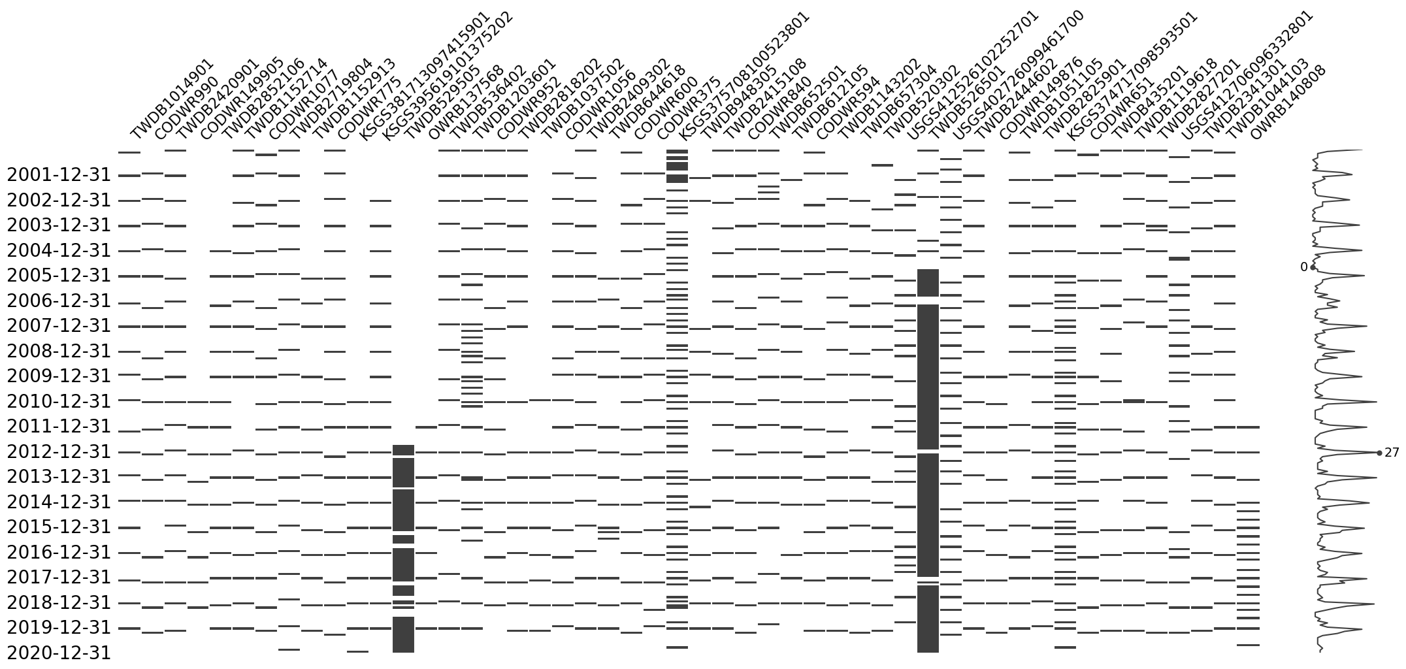

Figure 2. Distribution of monthly values across a sample of 50 wells in the Ogallala Aquifer (USA) from 2001 to 2020.

After applying the data selection methodology with a 90% threshold, 1.699 time series are accepted, representing 41% of the total number of monitoring stations. With an 80% threshold, this number increases to 2.562, accounting for 62% of the total number of monitoring stations.

Figure 3 shows the spatial distribution of the monitoring stations, before the selection, after the selection with 90% threshold, and after the selection with 80% threshold. We observe that the 80% threshold gives a better spatial distribution than the 90% threshold in some parts of the aquifer, such as Colorado and the northeastern part of Texas.

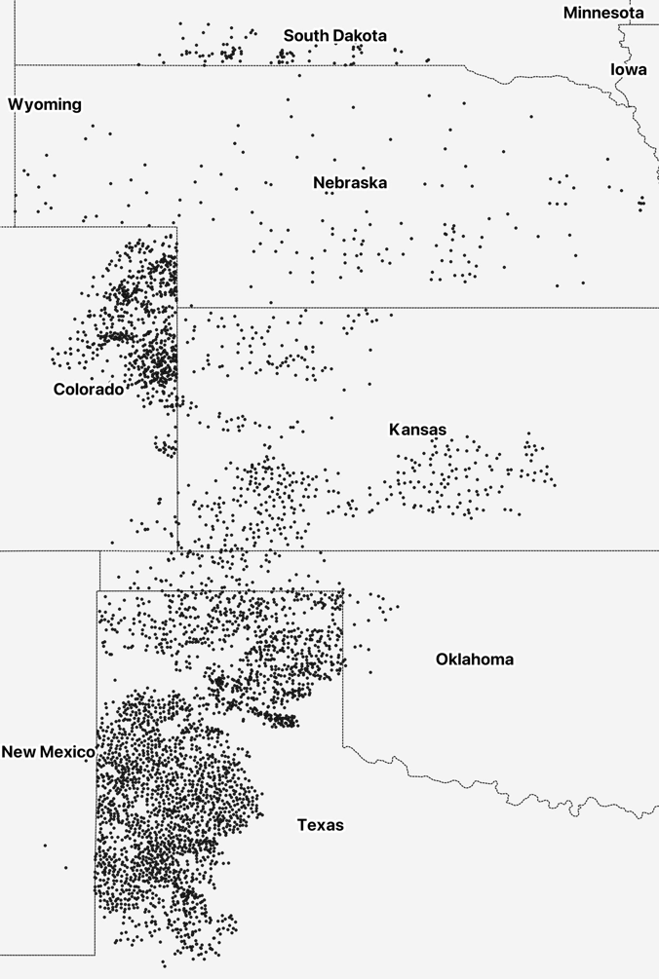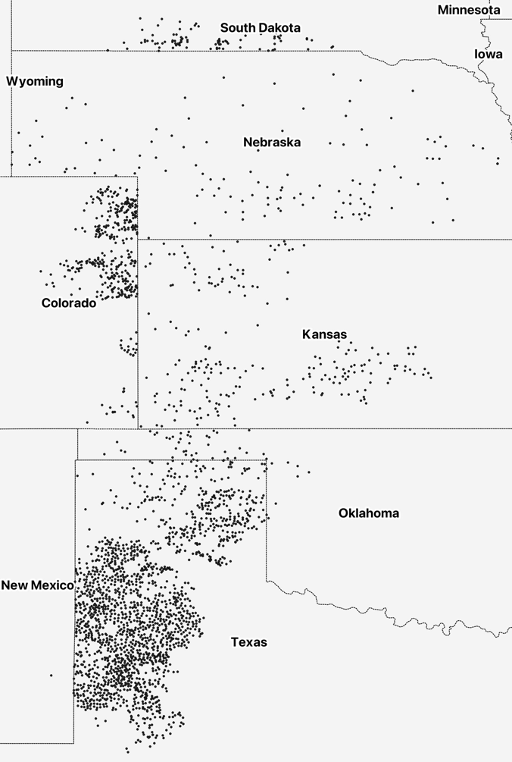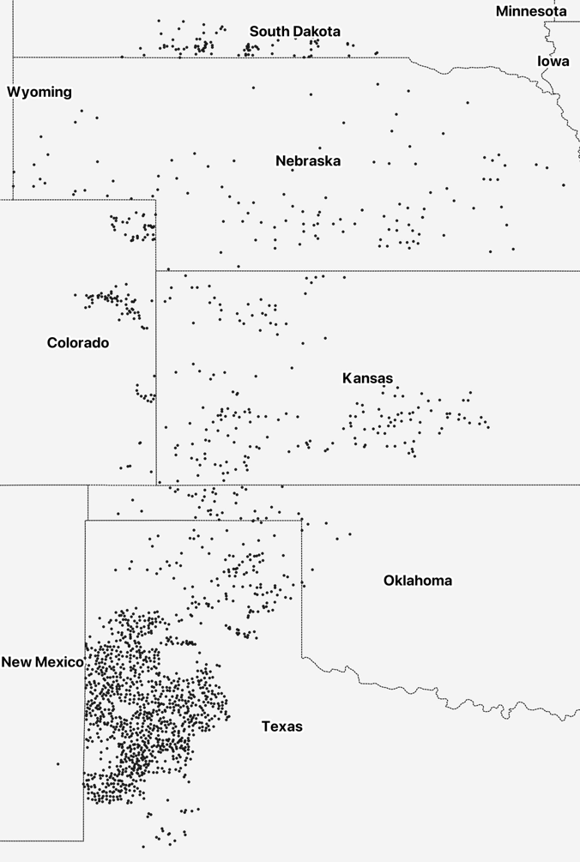

Figure 3. Spatial distribution of monitoring stations in the Ogallala Aquifer. a) displays all 4.100 wells, b) displays 1.699 wells accounting for 90% threshold, c) displays 2.562 wells accounting for 80% threshold.

c)

a)

b)

### Trend analysis

The Mann Kendall test was applied to the selected time series. An initial autocorrelation analysis was performed to determine whether the original Mann-Kendall or the modified Mann-Kendall test was appropriate. It happens that the time series often demonstrate dependencies between the values, as indicated by the autocorrelation, which frequently displays lag 1 or higher. Therefore the modified Mann-Kendall test has been performed on a majority of time series.

Table 1 shows the results of the Mann-Kendall tests performed on the selected time series. There is a excellent agreement between the results performed on the time series selected with a 90% and an 80% threshold.

Table 1. Trends resulting from the Mann-Kendall test in the Ogallala Aquifer, USA.

|  |  |  |  |
| --- | --- | --- | --- |
| Selection methodology  threshold | Mann-Kendall test trend / Percentage ratio | | |
| Increase | Decrease | No trend |
| 90% | 169 / 10% | 1115 / 66% | 415 / 24% |
| 80% | 246 / 10% | 1702 / 66% | 614 / 24% |

In certain cases, the absence of a trend may signify stability, while in other instances in could indicate uncertainty regarding a trend due to factors such as intra-annual cyclicity, abrupt shifts like steps due to pumping or environmental incidents, or other inherent phenomena present in groundwater level measurements. It is worth noting that the Mann-Kendall test, despite indicating either "trends" or "no trends," consistently produces a slope. For example, even when displaying "no trend," it will still yield a positive or negative slope. In such situations, it is advisable to introduce two additional categories, namely "No trend decreasing" and "No trend increasing," to better capture the nuanced aspects of the data.

In Figure 4 and Figure 5, the sign and the magnitude of the trends at each monitoring station have been mapped. Areas with intense groundwater depletion are easily recognized, such as the southwest of Kansas and the part of Texas with a high density of wells. This presentation is particularly advantageous for web-based visualization, especially when users have the option to zoom in for a more detailed examination as shown in Figure 6.

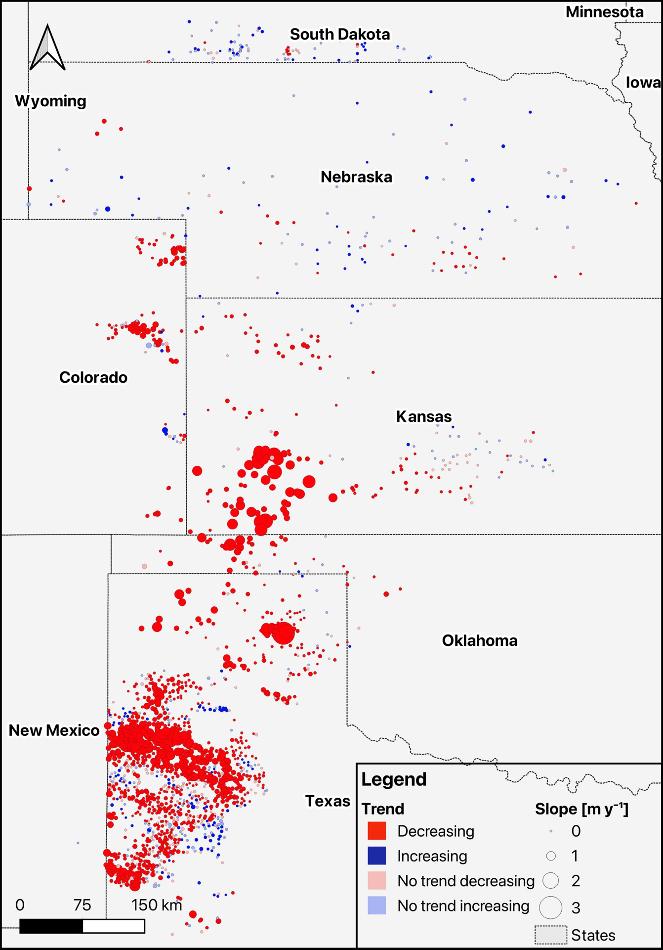

Figure 4. Trends and slopes resulting from Mann-Kendall tests in the Ogallala Aquifer (90% threshold selection).

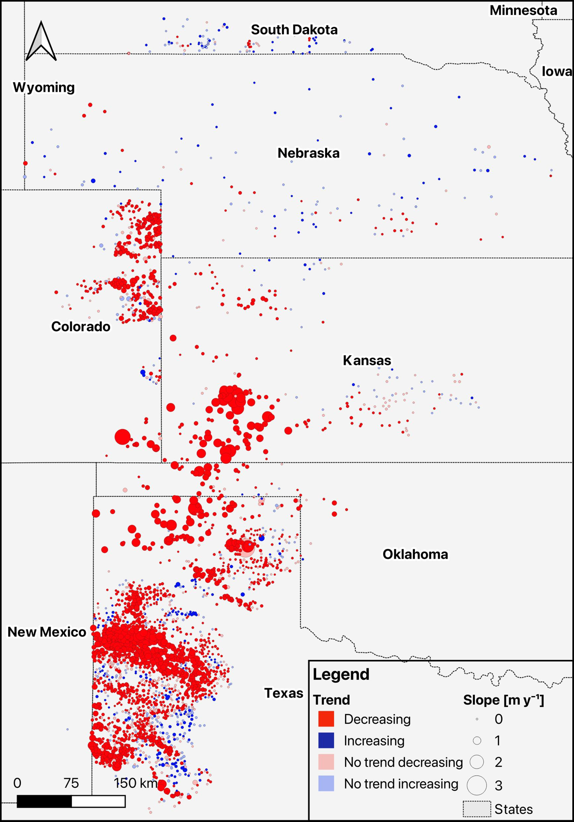

Figure 5. Trends and slopes resulting from Mann-Kendall tests in the Ogallala Aquifer (80% threshold selection).

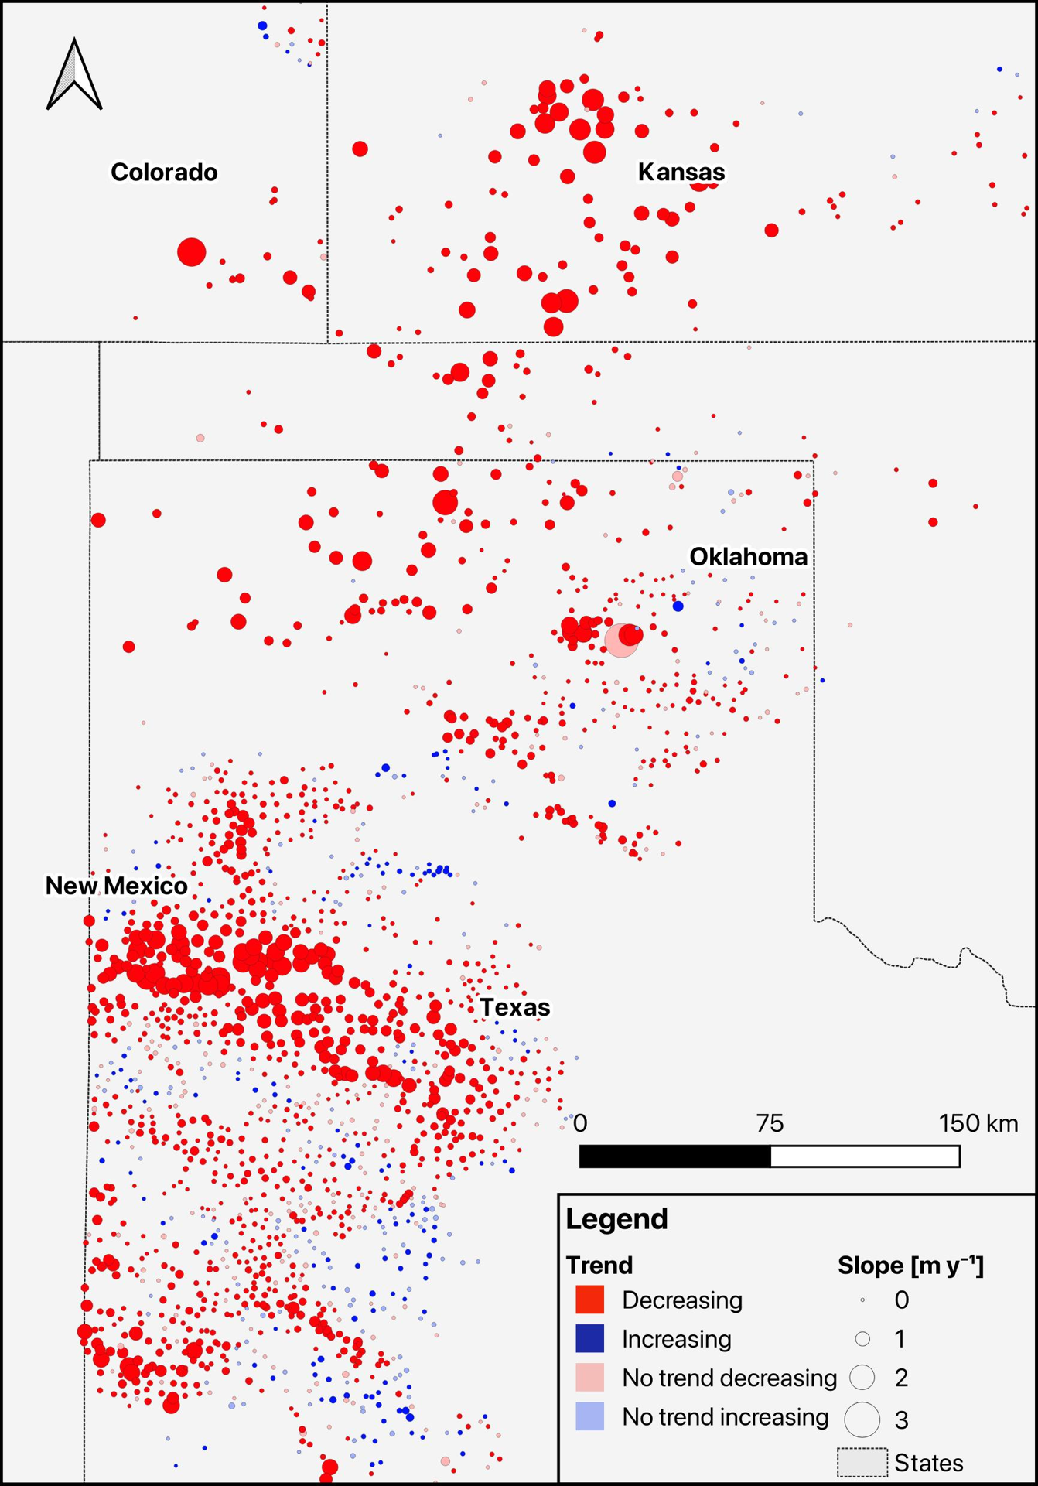

Figure 6. Zoom of Figure 4.

## Chile

Between 2001 and 2020, Chile had a total of 740 observation wells with at least one recorded measurement during this period. After applying the current selection methodology with a 90% threshold, 319 wells were accepted, representing 43 % of total wells. With an 80% threshold, this number increases to 385, accounting for 52% of the total wells (Table *2*). As in the Ogallala Aquifer, there is a very good agreement between the results performed on the time series selected with a 90% and an 80% threshold.

Table 2. Trends resulting from the Mann-Kendall test in Chile.

|  |  |  |  |
| --- | --- | --- | --- |
| Selection methodology  threshold | Mann-Kendall test trend / Percentage ratio | | |
| Increase | Decrease | No trend |
| 90% | 20 / 6% | 241 / 76% | 58 / 18% |
| 80% | 20 / 5% | 299 / 78% | 66 / 17% |

The spatial visualization of wells has been performed is presented in Figure 7 and Figure 8.

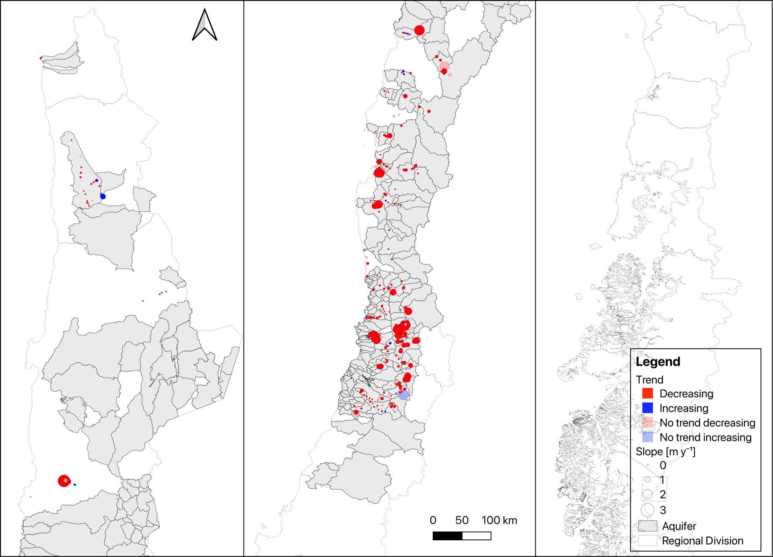

Figure 7. Trends and slopes resulting from Mann-Kendall tests in Chile (90% threshold selection).

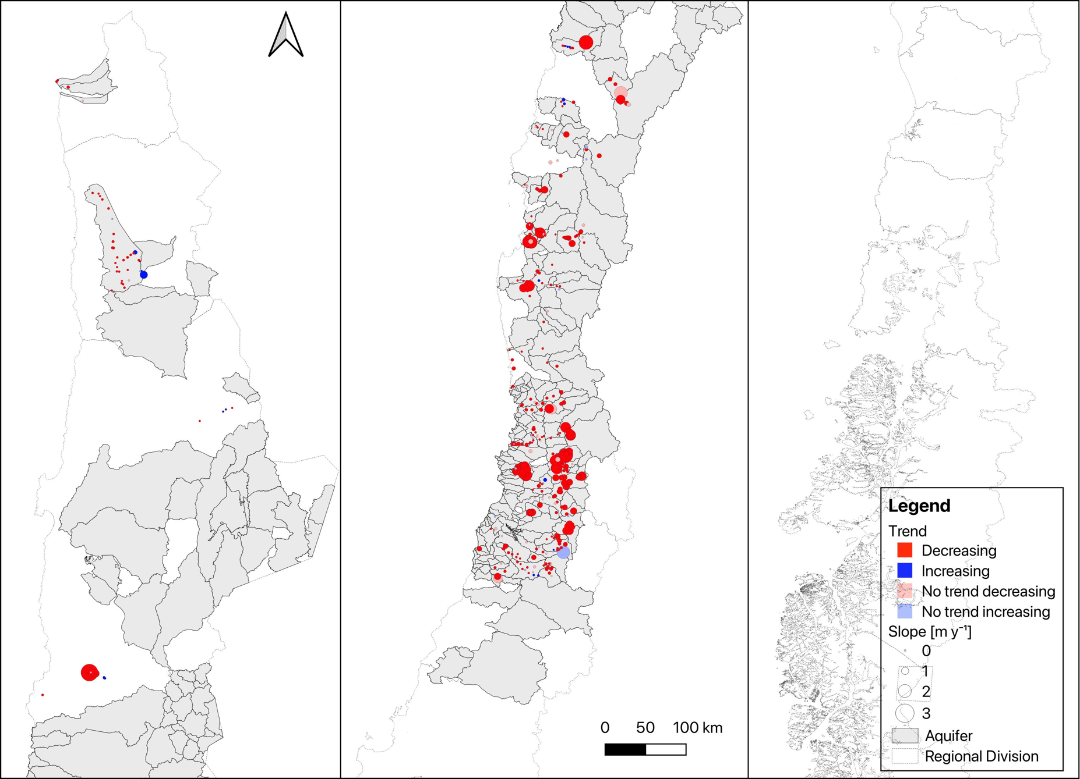

Figure 8. Trends and slopes resulting from Mann-Kendall tests in Chile (80% threshold selection).

## Benefits of the new methodology

Many studies evaluating groundwater level trends often aggregate data into monthly or yearly means, following some form of filtering or determination of a minimum amount of data per period. In both scenarios, without careful data selection, situations like the one depicted in Figure 9 could occur. On that figure, the well has data for the entire 20-years period, but there has been a change in the frequency of measurements. This is relatively common in groundwater monitoring, and it can have a significant impact on the performance of the Mann-Kendall test, because the test will assign more weight to the section of the time series where the density of data is higher. Simultaneously, if an unbalanced dataset undergoes yearly mean aggregation, the results could be the opposite, as illustrated in this same example. With the proposed methodology, such issues are overcome.

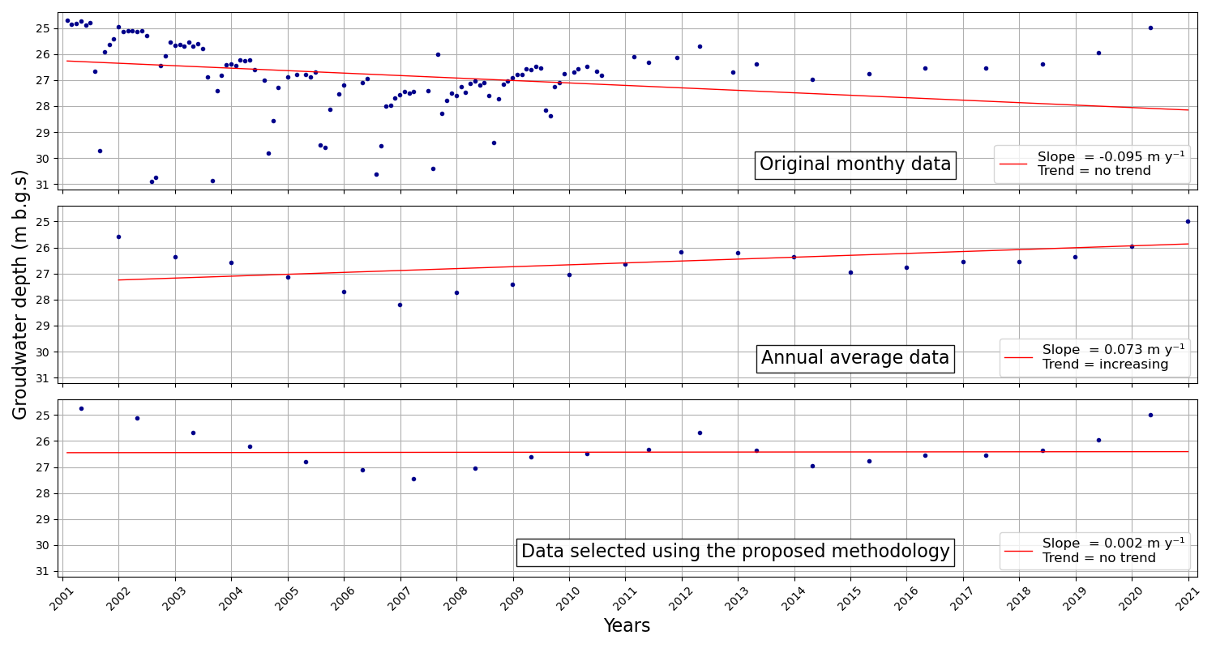

Figure 9. Mann-Kendall test performed on a time series with monthly values, annual averages, and monthly values as selected with the proposed methodology (Nebraska well Nº 405305097351503).

Another aspect to consider is the significance level applied in the Mann-Kendall test, which plays a pivotal role in determining the presence or absence of a trend. Opting to reduce the significance level from the standard 95% to 90% can prevent instances like those depicted in Figure 10. In this scenario, a declining trend might be perceived, but the test with a 95% significance level would lead to rejection. This situation is particularly relevant when dealing with datasets characterized by lower measurement density, such as 16 or 18 measurements representing only one month of data each year. In such cases, the limited data points may not provide enough support for the test to accept the alternative hypothesis, despite being in the presence of a trend.

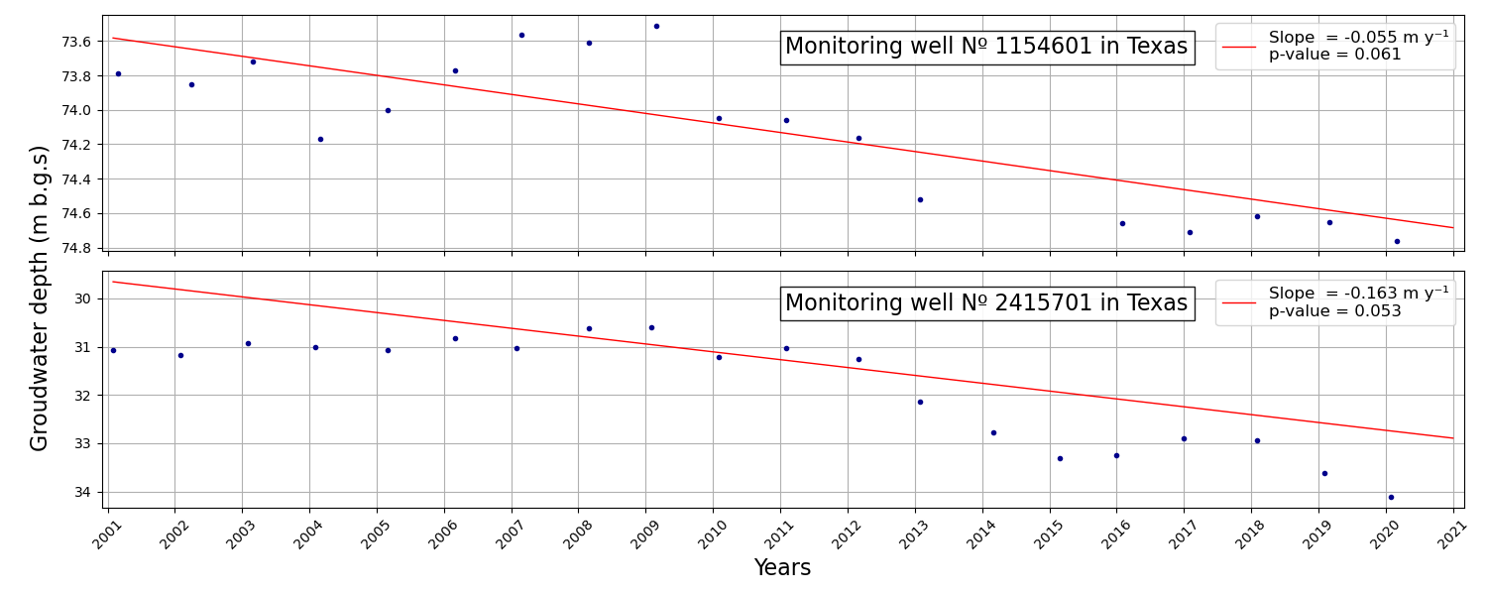

Figure 10. Impact of the significance level of the Mann-Kendall test on the results of the test.

## Further remarks

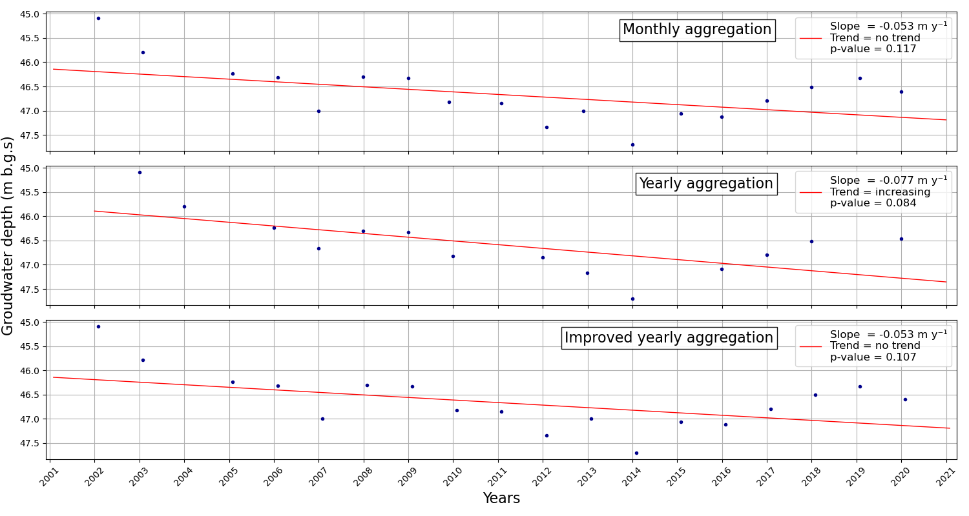The methodology relies on monthly values, yet it is a common practice to work with annual average values. However, when using annual averages, especially in cases where there's only one data point per year, and the selected month is December or January, as in the Ogallala Aquifer, it can result in data reduction for the entire period. This occurs because, in the computation of the yearly mean, all measurements taken within a single calendar year are included. For instance, if measurements are selected in January 2022 and December 2022 (substituting January 2023), and yearly mean is applied, the series will actually lose the data from 2023. This can result in distortions in the slope and the power of the Mann-Kendall test due to the artificial reduction of data, as illustrated in Figure 11. In case yearly values aggregation is needed, it is recommended to use an improved yearly aggregation method.

Figure 11. Comparison between monthly, yearly, and improved yearly aggregation in well Nº 2450204 located in Texas.

Another aspect of aggregation is illustrated in Figure 12. In this example, Mann-Kendall test is performed on a time series of 20 values. For the sake of the test, the values can be handled as monthly values, or yearly mean values. Although both sets of values are identical, the outcomes of the test will be different. This is because the monthly time series contains 20 values out of 240, whereas the yearly time series contains 20 values out of 20.

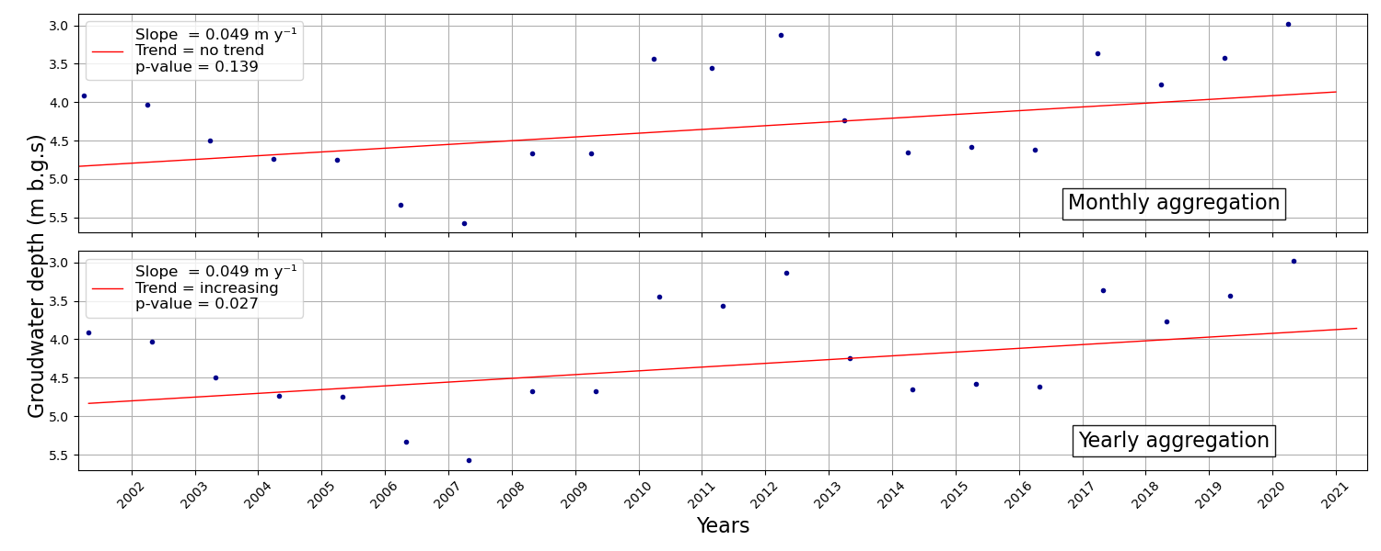

Figure 12. A comparative, examining both monthly and yearly aggregations, with each analysis based on a single data point per year (Nebraska well Nº 410102102232301).

# Acknowledgements

The authors are grateful to the organizations that have made their groundwater data available, either upon request or through online platforms:

|  |
| --- |
| * General Water Directorate (DGA), Chile |
| * United States Geological Survey (USGS) |

# References

Barclay, J.R., Mullaney, J.R., 2020. Updating Data Inputs, Assessing Trends, and Evaluating a Method To Estimate Probable High Groundwater Levels in Selected Areas of Massachusetts. https://doi.org/https://doi.org/ 10.3133/ sir20205036

Croiset, N., Neaud, C., Henriot, A., 2018. Manuel utilisateur Hypiz. Rapport final. BRGM/RP-68344- FR.

Daneshvar Vousoughi, F., Dinpashoh, Y., Aalami, M.T., Jhajharia, D., 2013. Trend analysis of groundwater using non-parametric methods (case study: Ardabil plain). Stoch. Environ. Res. Risk Assess. 27, 547–559. https://doi.org/10.1007/s00477-012-0599-4

Fu, G., Rojas, R., Gonzalez, D., 2022. Trends in Groundwater Levels in Alluvial Aquifers of the Murray–Darling Basin and Their Attributions. Water (Switzerland) 14, 1–26. https://doi.org/10.3390/w14111808

Hamed, K.H., 2008. Trend detection in hydrologic data: The Mann-Kendall trend test under the scaling hypothesis. J. Hydrol. 349, 350–363. https://doi.org/10.1016/j.jhydrol.2007.11.009

Hamed, K.H., Rao, R.A., 1998. A modified Mann-Kendall trend test for autocorrelated data. J. Hydrol. 204, 182–196. https://doi.org/10.1016/S0022-1694(97)00125-X

Hirsch, R.M., Slack, J.R., Smith, R.A., 1982. Techniques of trend analysis for monthly water quality data. Water Resour. Res. 18, 107–121. https://doi.org/10.1029/WR018i001p00107

Hussain, M., Mahmud, I., 2019. pyMannKendall: a python package for non parametric Mann Kendall family of trend tests. J. Open Source Softw. 4, 1556. https://doi.org/10.21105/joss.01556

IGRAC, 2023. State of Global Water Resources Report - Quantitative status of groundwater -.

Le Brocque, A.F., Kath, J., Reardon-Smith, K., 2018. Chronic groundwater decline: A multi-decadal analysis of groundwater trends under extreme climate cycles. J. Hydrol. 561, 976–986. https://doi.org/10.1016/j.jhydrol.2018.04.059

Pathak, A.A., Dodamani, B.M., 2019. Trend Analysis of Groundwater Levels and Assessment of Regional Groundwater Drought: Ghataprabha River Basin, India. Nat. Resour. Res. 28, 631–643. https://doi.org/10.1007/s11053-018-9417-0

QGIS.org, 2023. QGIS Geographic Information System.

Tabari, H., Nikbakht, J., Shifteh Some’e, B., 2012. Investigation of groundwater level fluctuations in the north of Iran. Environ. Earth Sci. 66, 231–243. https://doi.org/10.1007/s12665-011-1229-z

Wang, F., Shao, W., Yu, H., Kan, G., He, X., Zhang, D., Ren, M., Wang, G., 2020. Re-evaluation of the Power of the Mann-Kendall Test for Detecting Monotonic Trends in Hydrometeorological Time Series. Front. Earth Sci. 8, 1–12. https://doi.org/10.3389/feart.2020.00014

1. https://library.wmo.int/records/item/68473-state-of-global-water-resources-report-2022
2. https://github.com/UNIGRAC/Global-Reporting-Groundwater-Levels
3. https://cida.usgs.gov/ngwmn/index.jsp
4. https://snia.mop.gob.cl/BNAConsultas/reportes
5. https://dga.mop.gob.cl/estudiospublicaciones/mapoteca/Paginas/Mapoteca-Digital.aspx